F2 Franklin Farm Website – Classwork – (40 pts—10 pts each page)

- Create a site definition
- Copy the images from the global drive into the site’s images folder.
- Copy the entire word folders from global drive to the site.
- Create a 4-page website with links on each page.
- Create a banner inside Illustrator > 800 pixels wide x 100 pixels tall; format with basic graphic style; add text and a nature symbol from the symbol library. Save for the web

- Set background color of page properties to: #D6FBD0
- Set the hyperlink color to: #006600
- Set the rollover hyperlink color to: #FF6633

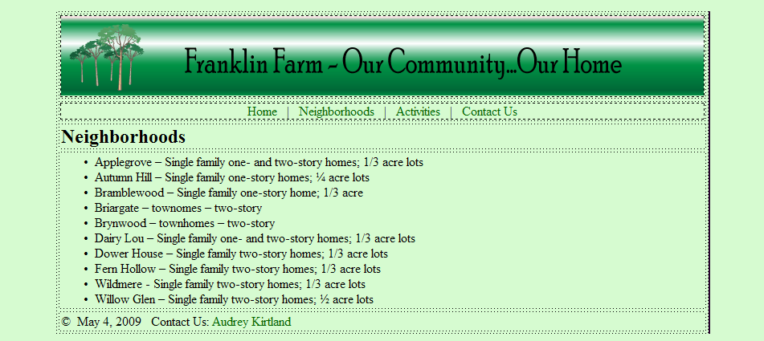
Save as: index.html

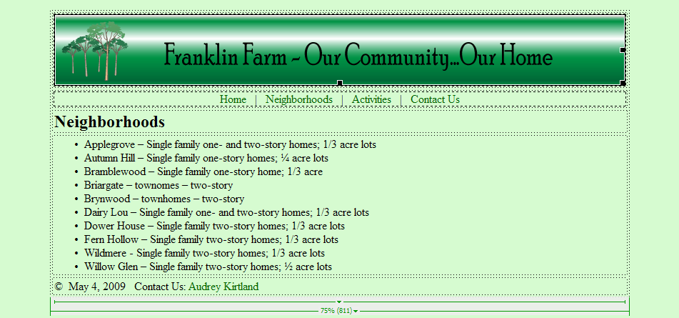
Save as: neighborhoods.html

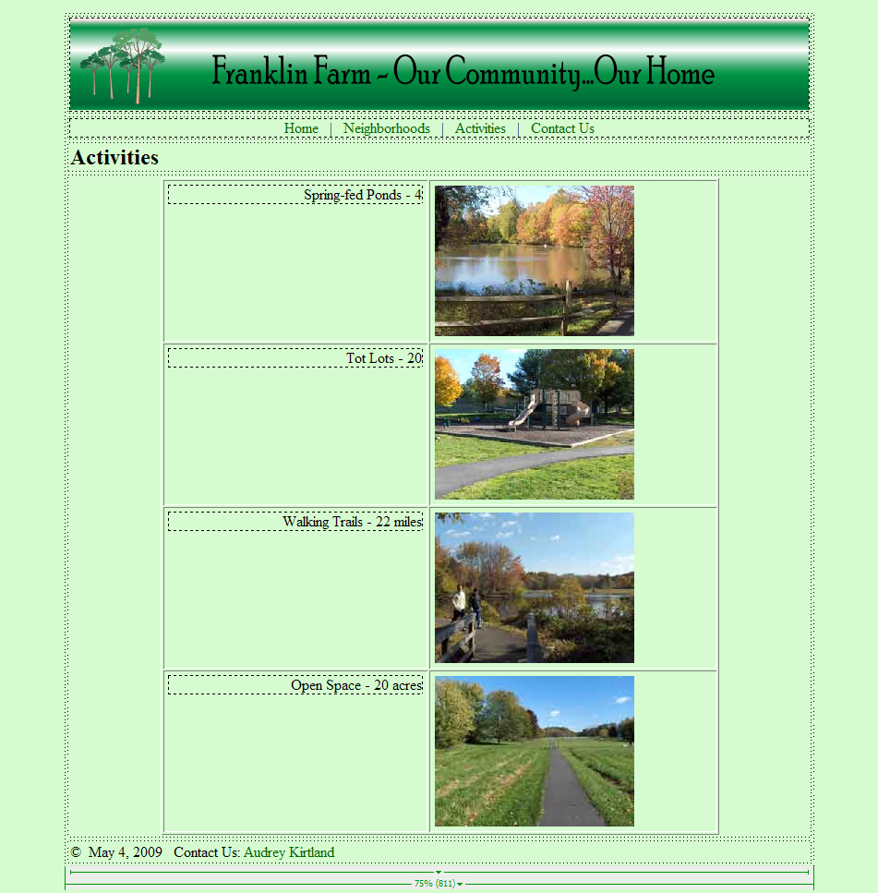
Save As: activities.html

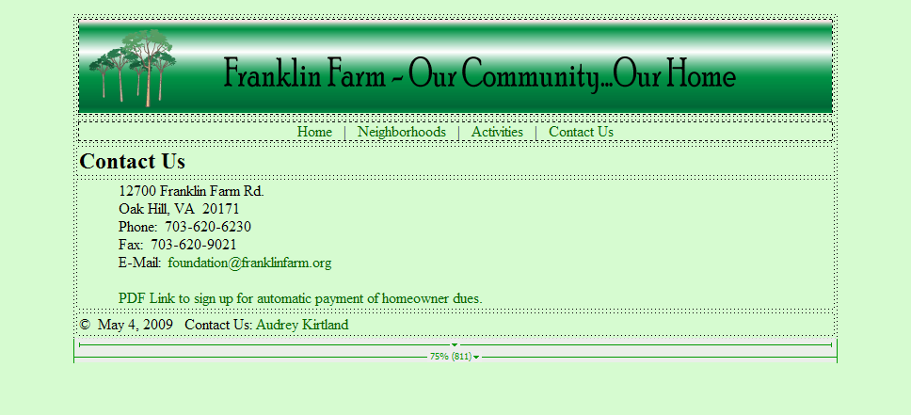
Save As: contact_us.html

